|  |  |
| --- | --- |
| Lab 1 | |
| ECE 380 W21 | |
| Group 8 | |
| Arjun Bawa, a3bawa | Andrew Tran, a89tran |

Table of Contents

Declaration of Authorship 3

1.1 4

1.2 5

1.3 6

1.1 6

1.2 6

1.4 7

1.5 8

1.6 9

1.7 10

1 10

2 11

3 & 4 12

5 & 6 13

7 & 8 14

9 15

10 16

DC Gain 18

Bandwidth 18

11 19

Time Constant 20

Settling Time 20

12 20

# Declaration of Authorship

We acknowledge and promise that:

1. We are the sole authors of this lab report and associated simulation files/code.
2. This work represents our original work.
3. We have not shared detailed analysis or detailed design results, computer code, or Simulink diagrams with any other student.
4. We have not obtained or looked at lab reports from any other current or former student of ECE/SE 380, and we have not let any other student access any part of our lab work.
5. We have completely and unambiguously acknowledged and referenced all persons and aids used to help us with our work.

|  |  |
| --- | --- |
| Student1 Name and Signature:  **Arjun Bawa** | Student2 Name and Signature:  **Andrew Tran** |

# 1.1

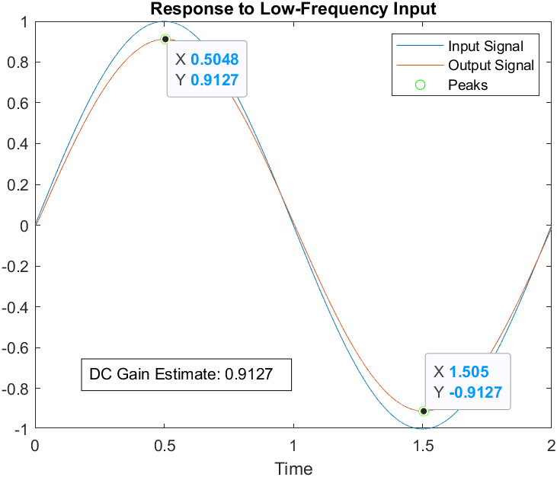

$$DC Gain≈\frac{0.9127-\left(-0.9127\right)}{1-\left(-1\right)}≈0.9127$$

# 1.2

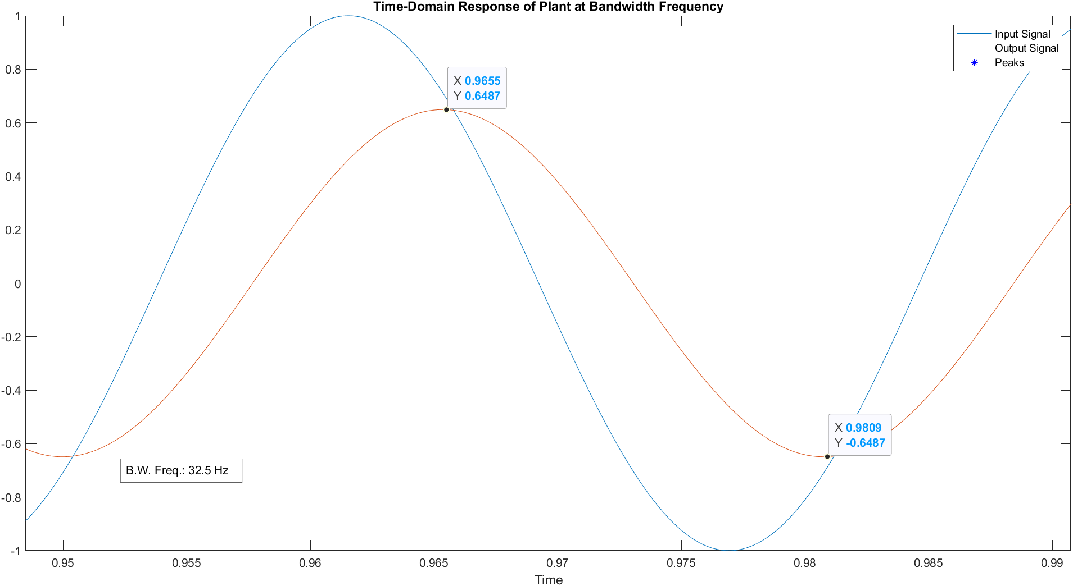

$$Gain at bandwidth frequency≈\frac{0.9127}{\sqrt{2}}≈0.6454$$

$⇒f_{bw}≈32.5 Hz$

# 1.3

## 1.1

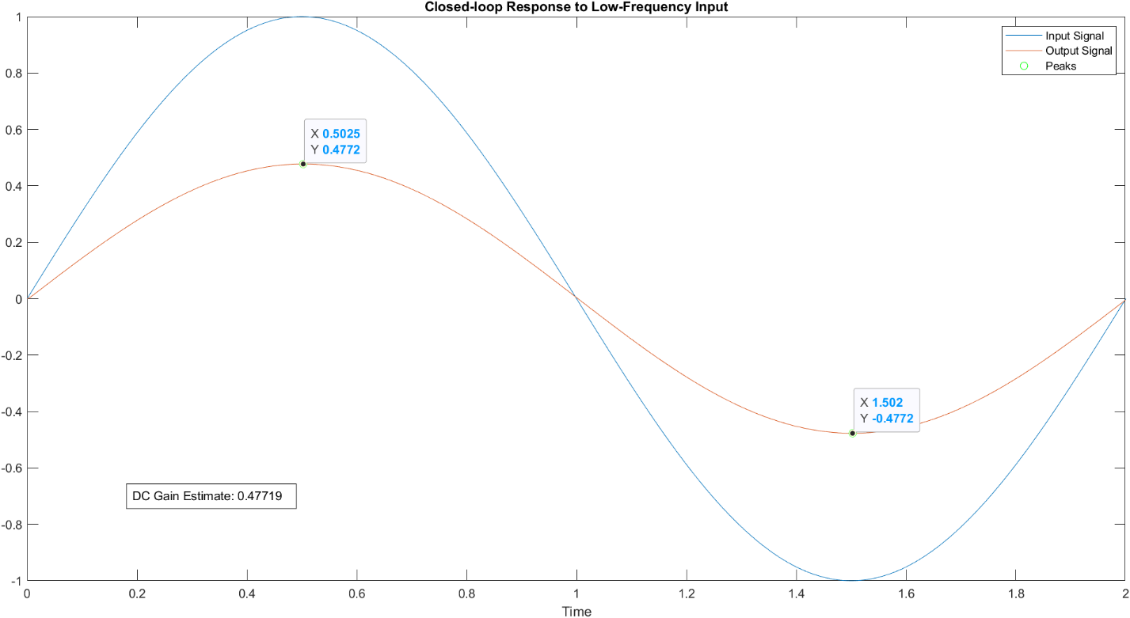

$$Closed-loop DC Gain≈0.4772$$

## 1.2

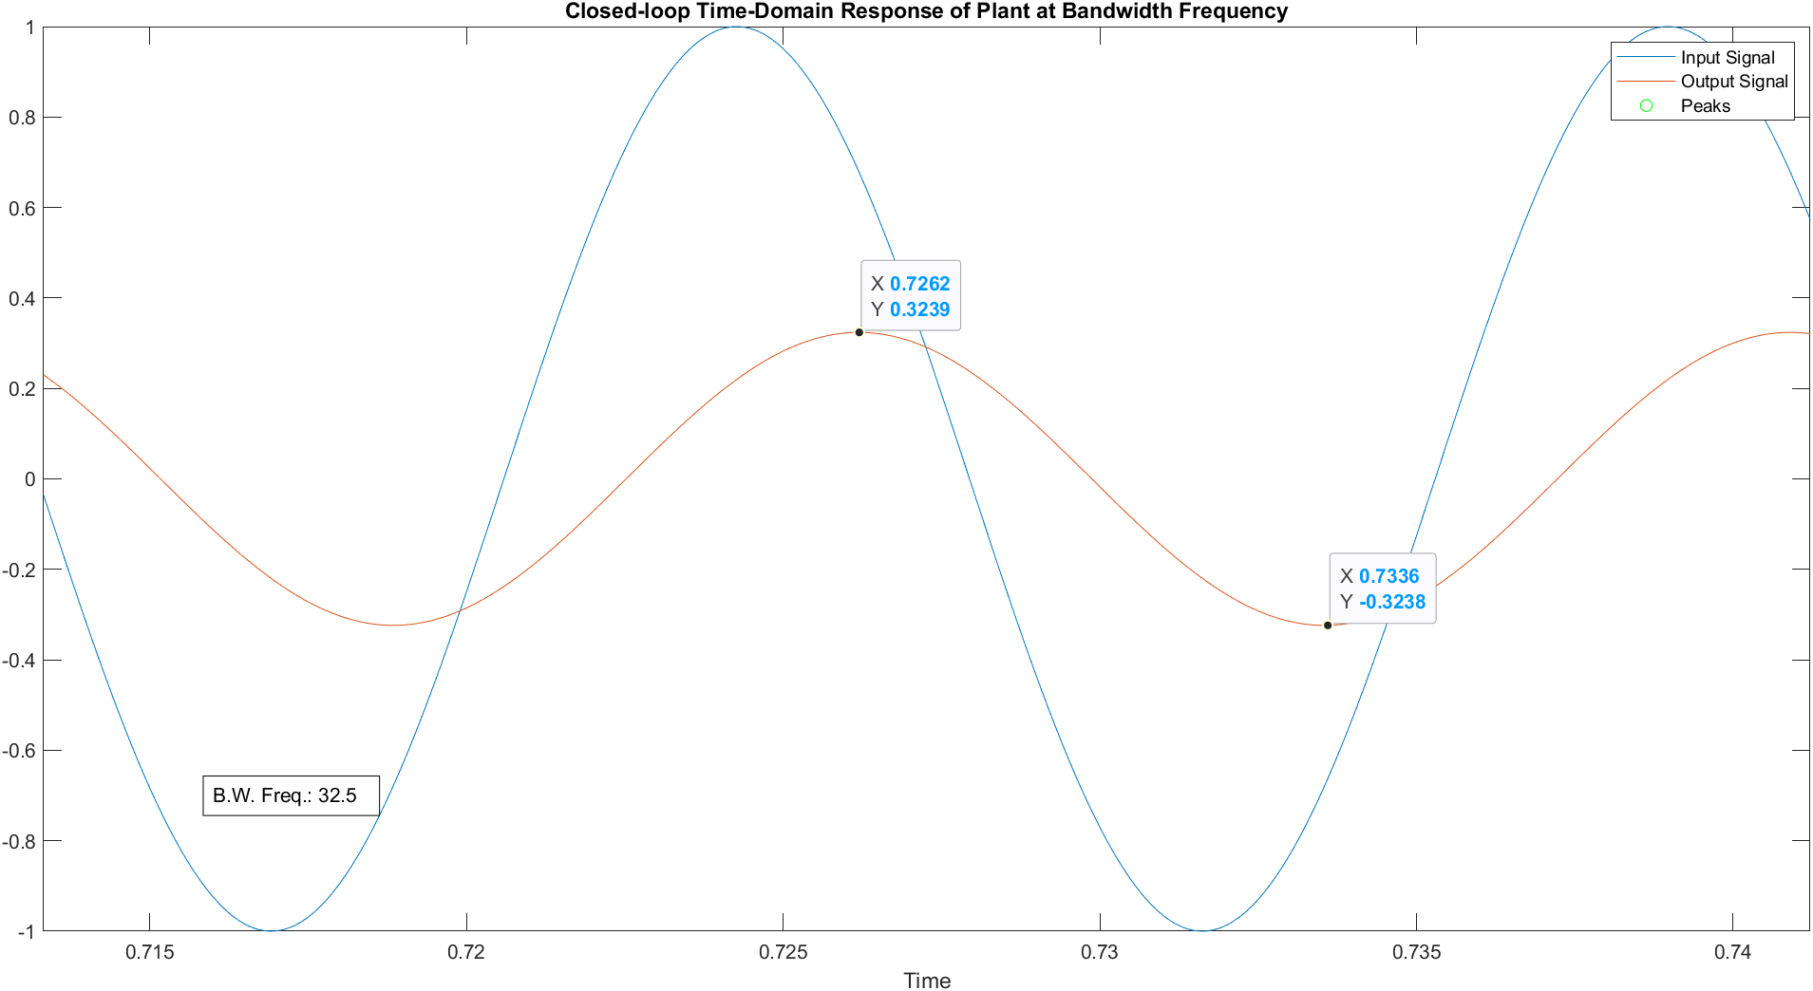

$$Gain at bandwidth frequency≈\frac{0.4772}{\sqrt{2}}≈0.3374$$

$$Gain measured≈\frac{0.3239-\left(-0.3238\right)}{1-\left(-1\right)}≈0.3239⇒Error=\frac{\left|0.3239-0.3374\right|}{0.3374}≈4\%$$

$$Bandwidth Frequency≈32.5 Hz$$

# 1.4

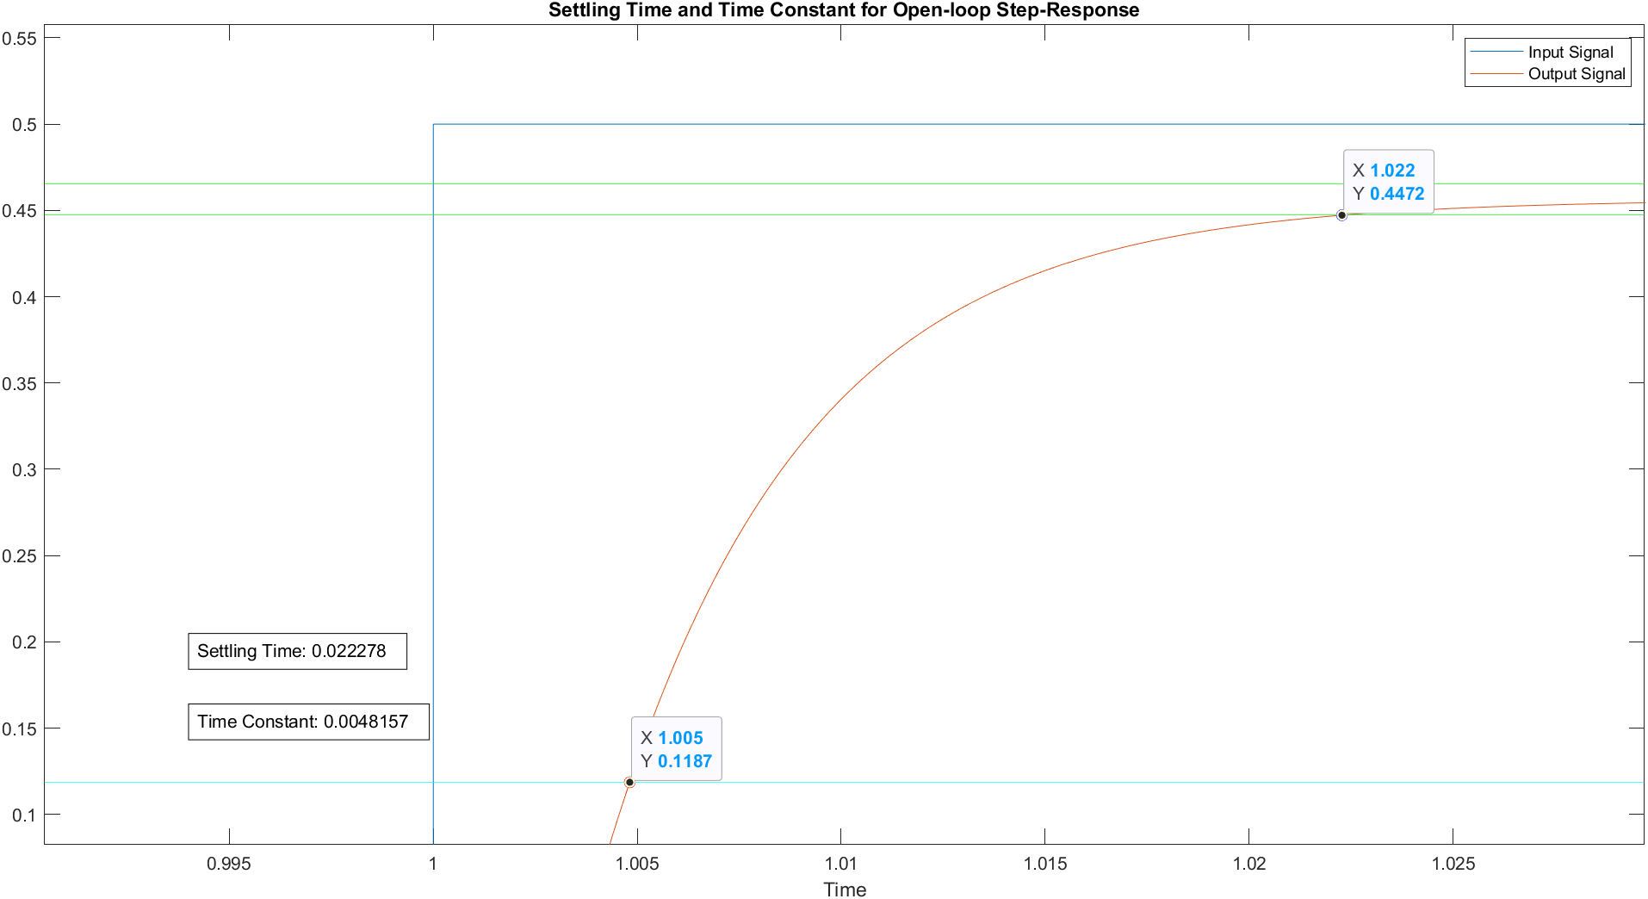

$$y\left(τ\right)≈0.9127×63\%+\left(-\frac{0.9127}{2}\right)≈0.11865$$

$$2\% lower threshold≈\frac{0.9127}{2}×98\%≈0.4472$$

$$2\% higher threshold≈\frac{0.9127}{2}×102\%≈0.4655$$

$$⇒ τ≈0.0048157 s$$

$$⇒ t_{settle}≈0.022278 s$$

# 1.5

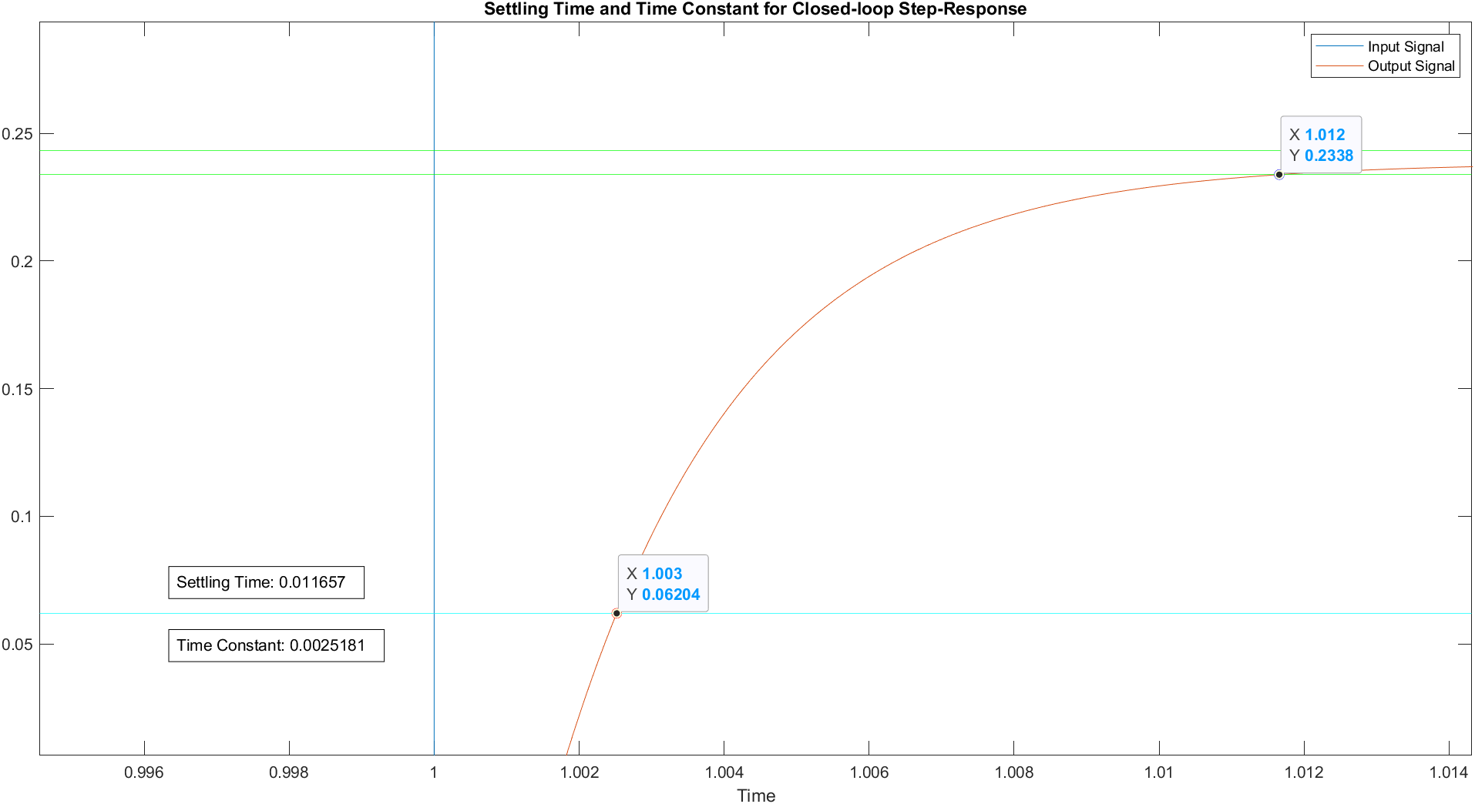

# 1.6

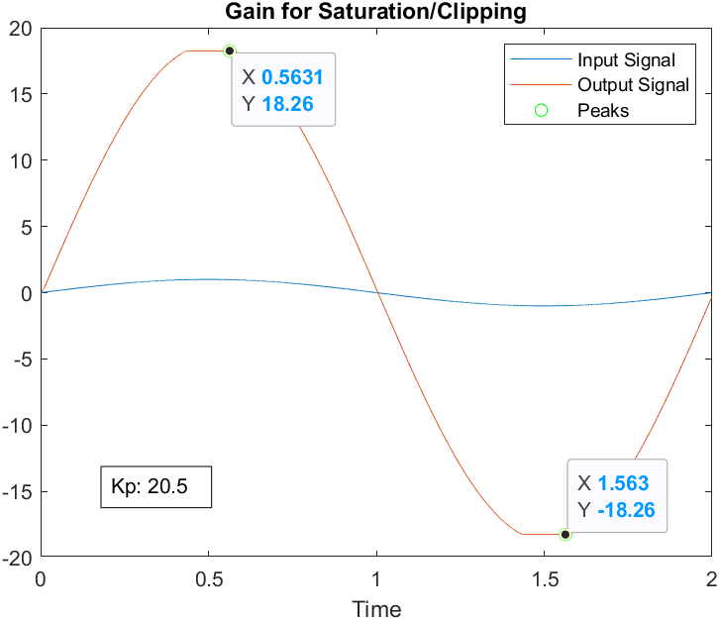

# 1.7

## 1

## 2

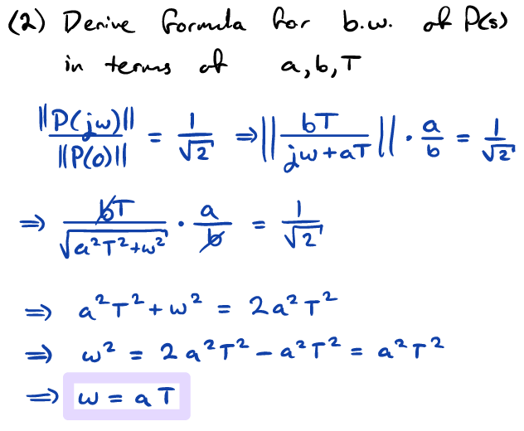

## 3 & 4

## 5 & 6

## 7 & 8

## 9

## 10

### DC Gain

Closing the loop results in lower DC gain. Intuitively, this makes sense. Closing the loop onto the negative terminal of the summer effectively applies negative feedback to the system. In general, negative feedback is used to regulate the output of a system (to ensure it doesn’t amplify in an unbounded way and cause erroneous behavior on the system). Usually, negative feedback controls (i.e. brings down) large gain to “wrangle” it back into acceptable range.

### Bandwidth

Closing the loop results in higher bandwidth. We’ve established that closing the loop decreases DC gain, and bandwidth is the frequency at which the ratio between the magnitude of the transfer function output and its DC gain is $\frac{1}{\sqrt{2}}$. If the DC gain decreases, the magnitude of the transfer function must increase to maintain the equality of the ratio. Hence, the bandwidth frequency increases, and the ratio is maintained.

## 11

### Time Constant

Closing the loop results in a smaller time constant. Considering that closing the loop (creating negative feedback) overall reduces the magnitude of the DC gain (and thereby also reducing the steady-state value), the system takes less time to reach 63% of this lowered steady-state value, meaning the time constant would be smaller than the open-loop scenario.

### Settling Time

Closing the loop results in a smaller settling time. This makes sense with a similar argument for the time constant. Closing the loop reduces DC gain of the system, decreasing the steady-state value of the system. This means the system reaches within 2% of the steady-state value sooner than in the open-loop case (since the steady-state value it must reach is lower and the system’s “speed” of response is unchanged).

## 12

Saturator limits are important to know because they often have non-linear effects on the system’s response. If we design control systems without taking saturation into consideration, the system can have undefined behavior. In the best case, this can cause the system to not behave as designed. For sensitive applications, this can lead to catastrophic damage.